The Glacier Dice Game
What happens to a glacier in a stable climate and in a warming one?
Name: ______________________________ Date: ____________

Background
We have already discussed how glaciers change size — how snow builds up in the accumulation zone and melts away in the ablation zone, and how the difference between these two processes determines whether a glacier grows, shrinks, or stays the same. The relationship between what is added and what is removed from the glacier is its mass balance.

In this activity, you will simulate 20 years of a glacier's life using two dice. Each year, you will roll:
- A blue die → represents accumulation (snowfall and ice gain)
- A red die → represents ablation (melting, evaporation, calving)
The difference between them is your glacier's balance for that year.

Your glacier will start with a mass of 30 gigatons. This is roughly the size that many mountain glaciers in the western US and Canada were at the beginning of the 1900s. One famous mountain glacier that tourists have been visiting for many years is the Athabasca Glacier in British Columbia, Canada (shown below).
Note: A gigaton is 1 billion tons! 1 gigaton of water could fill nearly 500,000 Olympic sized swimming pools. To put it another way, 1 gigaton of water could supply a city of 1 million people enough drinking water for about 3 years!
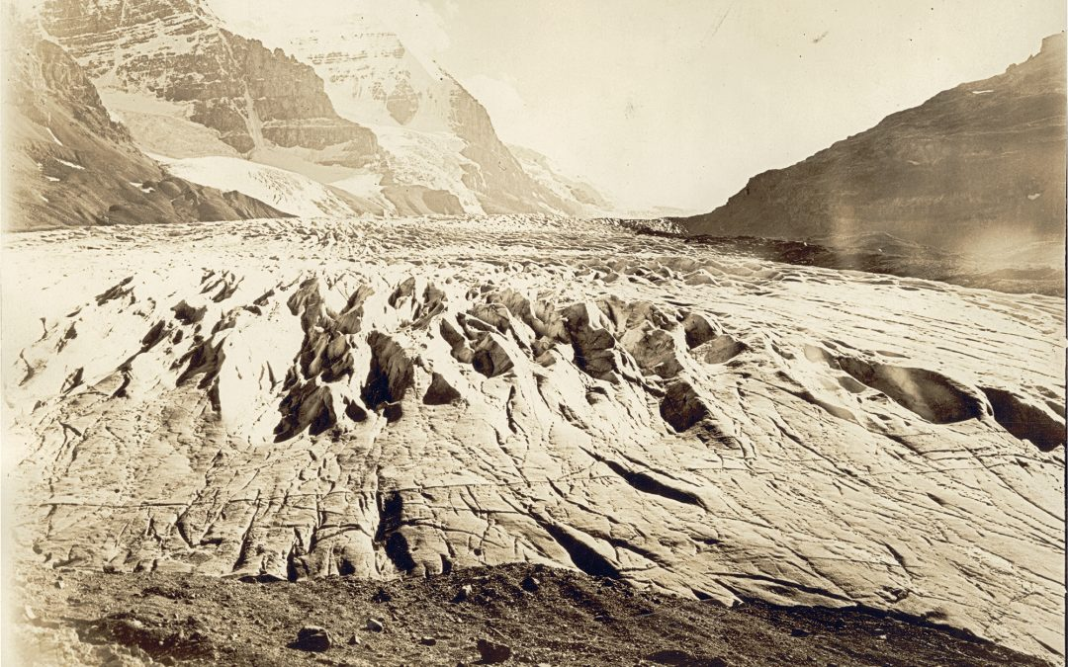

Athabasca Glacier in 1917. Photograph from the Arthur Wheeler Interprovincial Boundary Survey.
Phase 1 — Natural climate (years 1–10)
Roll both dice 10 times. Each roll = one year. Record your results below.
Calculate balance as: blue die − red die. Add it to the running mass each year (mass can't go below 0).

Year | Blue die (Accumulation) | Red die (Ablation) | Balance  (Blue − Red) | Total Mass  (Gigatons)
Start | - | - | - | 30
1
2
3
4
5
6
7
8
9
10

Mass at end of Phase 1: __________ gigatons

Mass trend at end of Phase 1 $\left(\frac{Mass at year 10 - Mass at start}{10 years}\right)$: __________ gigatons/year

Phase 2 — Warming climate (years 11–20)
The climate is warming. Add +2 to every red die roll. Everything else stays the same.
Continue rolling for 10 more years. Record your results below.
Balance = blue die − (red die + 2). Keep your total mass from where Phase 1 ended.

Year | Blue die (Accumulation) | Red die (Ablation) | Balance  (Blue − Red) | Total Mass  (Gigatons)
11
12
13
14
15
16
17
18
19
20

Mass at end of Phase 2: __________ gigatons

Mass trend at end of Phase 2 $\left(\frac{Mass at year 20 - Mass at year 10}{10 years}\right)$: __________ gigatons/year

Total change over 20 years: _______ gigatons | Trend over 20 years: ______ gigatons/year

Plot your glacier's mass over time
Use the grid below to plot your running mass for each year (years 0–20). Mark the boundary between Phase 1 and Phase 2 with a dashed vertical line at year 10.
Mass (gigatons)
0
50
40
30
20
10
Time (years)
20
10
5
15

Questions
Answer the questions below using your data and what you observed during the game.
1. During Phase 1 (natural climate), did your glacier gain mass, lose mass, or stay about the same? Was this what you expected? Explain why some groups might have gotten different results even though everyone used the same dice.
Think about what "random" means in a natural climate.
2. What happened to your glacier in Phase 2 when the +2 warming modifier was added to the red die? Describe the trend you see on your graph.
Look at your running mass — does it go up, down, or stay flat?
3. The +2 modifier represents a warmer climate increasing the ablation rate. In the real world, what causes ablation to increase as temperatures rise? Name at least two processes.
Hint: think beyond just surface melting.
4. Compare your Phase 1 and Phase 2 graphs with another group. Did both groups' glaciers grow or shrink in Phase 1? What about Phase 2? What does this tell you about the difference between random variation and a consistent warming trend?
This is similar to how scientists detect climate change in real data.
5. If the glacier represents a mountain glacier that feeds a river downstream, what might happen to that river over 20 years if the glacier keeps losing mass? Who might be affected?

6. A friend says: "One of the groups' glaciers actually grew during the warming phase, so the warming modifier doesn't really matter." Do you agree or disagree?
Think about why one outcome doesn't disprove a trend.

Athabasca Glacier in 1917 and 2011 from the same location.
